**ShopMe: An E-Commerce Website**

**A PROJECT REPORT**

***Submitted by***

**Md Sami Alam**

***in partial fulfillment for the award of the degree***

***of***

**COMPUTER SCIENCE & ENGENEERING**



**Lovely Professional University, Punjab**

**OCTOBER 2024**



**Lovely Professional University, Punjab**

**BONAFIDE CERTIFICATE**

Certified that this project report “**ShopMe: An E-Commerce Website”**

is the bonafide work of “ **Md Sami Alam”** who carried out the project work

under my supervision.

<<Signature of

**SIGNATURE**

<<Name>>  
**CLASS MENTOR**

<<Signature of the Head of the Department>>

**SIGNATURE**

<<Name>>  
**HEAD OF THE DEPARTMENT**

<<Signature of the Supervisor>>  
**SIGNATURE**<<Name>>

**SUPERVISOR**

<<Full address of the Deptt. & Organization >>

 **LIST OF CONTENTS**

**Chapter Particulars Page No.**

1. **Project Title………………………………………… 01**
2. **Bonafide Certificate………………………………… 02**
3. **List Of Contents….………………….………….… 03**
4. **Introduction……….…………………..…………… 04 -05**

**5. Technology Used.………….……………………… 06**

**6. Working of Project..……………………………… 07**

1. **Code Snippets….……………………….……… 08-20**
2. **Webpage SNAPSHOTS………………….…………21-28**
3. **References …………………………….…………....29**

### **INTRODUCTION**

**Introduction to ShopMe:**

In the rapidly evolving digital landscape, e-commerce has emerged as a pivotal component of global commerce, transforming the way consumers interact with brands and products. The advent of technology has facilitated a significant shift from traditional brick-and-mortar stores to online shopping platforms, providing both consumers and businesses with unprecedented opportunities. Recognizing this trend, I embarked on the development of an e-commerce website, named **ShopMe**, as a frontend project aimed at demonstrating my skills in web development and my understanding of the e-commerce ecosystem.

**The Vision Behind ShopMe:**

The primary vision behind ShopMe is to create a user-friendly and engaging online shopping experience that caters to the needs of a diverse customer base. With a growing number of consumers preferring the convenience of online shopping, it is essential to design a platform that not only showcases products effectively but also simplifies the purchasing process. ShopMe aims to bridge the gap between consumers and products by providing an intuitive interface, seamless navigation, and responsive design.

**Importance of E-commerce in Today's Market:**

The significance of e-commerce cannot be overstated. According to recent studies, online retail sales have been consistently rising, with projections indicating a continued upward trajectory. E-commerce platforms allow businesses to reach a global audience, reduce overhead costs, and offer a wider range of products than traditional retail stores. For consumers, online shopping offers convenience, accessibility, and often better prices due to reduced operational costs.

In the context of these market dynamics, the development of ShopMe is not merely an academic exercise but a reflection of real-world needs. The project seeks to address common pain points faced by online shoppers, such as cumbersome navigation, lack of product information, and complicated checkout processes.

not only showcases products effectively but also simplifies the purchasing process. ShopMe aims to bridge the gap between consumers and products by providing an intuitive interface, seamless navigation, and responsive design.

**Goals and Objectives:**

The primary goal of ShopMe is to create a user-friendly e-commerce platform that enhances the online shopping experience. To achieve this overarching goal, I defined several specific objectives that guided the development process:

**User Experience**

* **Intuitive Interface**: One of the foremost objectives was to design an intuitive user interface that minimizes confusion and enhances usability. By focusing on clear navigation menus, straightforward product categories, and easy-to-find search functionality, I aimed to create a shopping experience where users can effortlessly find what they’re looking for
* **Visual Appeal**: The aesthetic aspect of the site was also crucial. By employing a clean and modern design with appealing color schemes, high-quality images, and well-structured layouts, I sought to engage users visually and create a positive first impression. This is vital in retaining customers and encouraging them to explore further.
* **Accessibility**: Ensuring that ShopMe is accessible to all users, including those with disabilities, was a significant objective. This included implementing features such as keyboard navigation, screen reader compatibility, and color contrast considerations to enhance usability for everyone.

### **Technologies UsedPage NO.: 06**

**HTML (HyperText Markup Language)**:

The backbone of the website, HTML is used to structure the content, including headers, paragraphs, images, links, and lists. It helps organize the information in a way that web browsers can display.

**CSS (Cascading Style Sheets)**:

CSS is employed for styling the HTML elements, allowing for customization of colors, fonts, layouts, and overall aesthetics. It enables responsive design through media queries, ensuring the site looks good on all devices.

**Font Awesome**:

This library provides a wide range of icons that enhance navigation and social media engagement. It allows for scalable vector icons that can be easily customized in size and color.

### **Working of the Project**

### **Page NO.: 07**

1. **Homepage Layout**: The homepage features a header with a logo, search bar, and navigation links. Below that a moving welcoming message is placed and a Navigation link in the form of big image for Beauty Products is given. And Below this ..there are Product cards And a Footer.
2. **Product Cards**: Each card includes title of the product, an image, and a link named See more to view more details about the product.
3. **Footer**: Contains company information, resources, and social media links for customer engagement.
4. **Responsive Design**: The website adjusts to different screen sizes, ensuring usability on both mobile and desktop devices.

HTML CODES And CSS for Home Page:

<!DOCTYPE html>

<html lang="en">

<head>

<meta charset="UTF-8">

<meta name="viewport" content="width=device-width, initial-scale=1.0">

<title>ShopMe</title>

<link rel="stylesheet" href="https://cdnjs.cloudflare.com/ajax/libs/font-awesome/6.6.0/css/all.min.css" integrity="sha512-Kc323vGBEqzTmouAECnVceyQqyqdsSiqLQISBL29aUW4U/M7pSPA/gEUZQqv1cwx4OnYxTxve5UMg5GT6L4JJg==" crossorigin="anonymous" referrerpolicy="no-referrer" />

<link rel="stylesheet" href="style.css">

</head>

<body>

<header>

<div class="navbar">

<div class="nav-logo border">

<div class="logo">

<a href="#">

<img src="Shopme-logo3.png" alt="">

</a>

</div>

</div>

<div class="nav-search">

<select class="search-select">

<option value="">All</option>

<option value="">Beauty</option>

<option value="">Toys</option>

<option value="">Women Clothes</option>

<option value="">Men's Shirts</option>

<option value="">Realme Mobiles</option>

<option value="">Men jeans</option>

<option value="">Books</option>

</select>

<input type="text" placeholder="Search For Products , Brands Etc " class="search-input">

<div class="search-icon">

<i class="fa-solid fa-magnifying-glass"></i>

</div>

</div>

<div class="nav-signin border">

<a href="#"><p>Hello,</p>

<p>Sign.in</p>

</a>

</div>

<div class="nav-my border">

<p><span>My</span></p>

<a href="#" target="_main" class="nav-second">Orders</a>

</div>

<div class="nav-cart border">

<a href="#">

<i class="fa-solid fa-cart-shopping"></i>

cart

</a>

</div>

</div>

<div class="panel">

<div class="panelall">

<i class="fa-solid fa-bars"></i>

All

</div>

<div class="panel-ops ">

<a href="#"><p>Today's Deals</p></a>

<a href="#"><p>Top Offers</p></a>

<a href="#"><p>Customer Service</p></a>

<a href="#"><p>Gift Cards</p></a>

</div>

<div class="panel-deals">

<a href="#"><p> Deals on Furmitures </p> </a>

<a href="#"><p>Electronics</p></a>

</div>

</div>

</header>

<div class="hero-section">

<div class="hero-msg">

<marquee behavior="" direction="">You are on ShopMe.com. We are Welcoming You all With Eye-Catching Offers.. We hope that you will find your choice! </marquee>

</div>

<!-- <div class="hero-sale-logo"><img src="Sale_logo.png" alt=""></div> -->

<div class="hero-image">

<a href="panel.html"><img src="hero_img2.jpg" alt=""></a>

</div>

</div>

<div class="shop-section">

<div class="box">

<div class="box-content">

<h2>Clothes</h2>

<div class="box-img" style="background-image: url('box1_image.avif');">

</div>

<a href="clothes.html"><p>See more</p></a>

</div>

</div>

<div class="box">

<div class="box-content">

<h2>Personal tools</h2>

<div class="box-img" style="background-image: url('box2_image.jpg');">

</div>

<a href="#"><p>See more</p></a>

</div>

</div>

<div class="box">

<div class="box-content">

<h2>Furnitures </h2>

<div class="box-img" style="background-image: url('box3_image.jpg');">

</div>

<a href="#"><p>See more</p></a>

</div>

</div>

<div class="box">

<div class="box-content">

<h2>Mobiles</h2>

<div class="box-img" style="background-image: url('box4_image.jpg');">

</div>

<a href="mobiles.html"><p>See more</p></a>

</div>

</div>

<div class="box">

<div class="box-content">

<h2>Beauty kits </h2>

<div class="box-img" style="background-image: url('box5_image.jpg');">

</div>

<a href="cosmetic.html"><p>See more</p></a>

</div>

</div>

<div class="box">

<div class="box-content">

<h2>Pet Care</h2>

<div class="box-img" style="background-image: url('box6_image.jpg');">

</div>

<a href="#"><p>See more</p></a>

</div>

</div>

<div class="box">

<div class="box-content">

<h2>New Arrival in Toys</h2>

<div class="box-img" style="background-image: url('box7_image.jpg');">

</div>

<a href="#"><p>See more</p></a>

</div>

</div>

<div class="box">

<div class="box-content">

<h2>Discover Fashing Trends</h2>

<div class="box-img" style="background-image: url('box8_image.jpg');">

</div>

<a href="#"><p>See more</p></a>

</div>

</div>

</div>

<!-- footer -->

<footer>

<div class="foot-panel1">

<a href="#">Back to top</a>

</div>

<div class="foot-panel2">

<ul>

<p>Get To know Us</p>

<a href="">Careers</a>

<a href="">About ShopME</a>

<a href="Authenticity"></a>

</ul>

<ul>

<p>Connect with Us</p>

<a href="">Instagram</a>

<a href="">Facebook</a>

<a href="">Twitter</a>

</ul>

<ul>

<p>Contact Us</p>

<a href="">Gmail : ShopMe@gmail.com</a>

Helpline No.1 : 62005***** <br>

Helpline No.2 : 9241******

</ul>

</div>

<div class="foot-panel3">

<div class="logo">

<a href="#">

<img src="Shopme-logo3.png" alt="">

</a>

</div>

</div>

<div class="foot-panel4">

<div class="pages">

<a href="">Condition of Use</a>

<a href="">Privacy Notices</a>

<a href=""></a>

</div>

<div class="copy-right">

&copy ShopMe.in affliated

</div>

</div>

</footer>

</body>

</html>

CSS :

*{

margin: 0;

font-family: Arial, Helvetica, sans-serif;

border: border-box; /* jitni bhi height and width humne di hui hogi uske andar he saara count ho.. border, padding wagaira */

}

.navbar{

height: 70px;

background-color: black;

color: white;

display: flex;

align-items: center;

justify-content: space-evenly;

}

/* box1 */

.nav-logo{

height: 57px;

width: 100px;

}

.logo img{

height: 63px;

width: 100px;

}

.border{

border: 2px solid transparent;

}

.border:hover{

border: 1.5px solid white;

}

/* box2 */

.nav-search{

display: flex;

justify-content: space-evenly;

background-color: pink;

width: 700px;

height: 42px;

border-radius: 4px;

}

.nav-search:hover{

border: 2px solid pink;

}

.search-select{

width: 52px;

text-align: center;

border-top-left-radius: 4px;

border-bottom-left-radius: 4px;

border: none;

background-color: rgb(241, 241, 241);

}

.search-input{

width: 100%;

font-size: 1em;

border: none;

}

.search-icon{

width: 50px;

display: flex;

justify-content: center;

align-items: center;

font-size: 1.2em;

color: black;

}

/* box3 and 4 */

span{

font-size: 0.8em;

color: white;

text-decoration: none;

}

.nav-second{

font-size: 0.95em;

font-weight: 700;

color: white;

text-decoration: none;

}

.nav-signin a{

color: white;

text-decoration: none;

}

/* box5 */

.nav-cart i{

font-size: 30px;

color: white;

}

.nav-cart a{

font-size: 0.85em;

font-weight: 700;

color: white;

text-decoration: none;

}

/* panel */

.panel{

height: 40px;

background-color: rgb(213, 150, 247);

display: flex;

align-items: center;

justify-content: space-evenly;

}

.panel-all{

margin-left: 50px;

}

.panel-ops p{

display: inline;

margin-left: 10px;

}

.panel-ops a{

text-decoration: none;

color: black;

}

.panel-ops{

width: 58%;

font-size: 0.85em;

font-weight: 600;

}

.panel-deals {

display: flex;

font-size: 0.9em;

font-weight: 700;

}

.panel-deals p{

margin-left: 20px;

}

.panel-deals a{

text-decoration: none;

color: black;

}

/* hero-section */

.hero-section{

/* background-image: url(hero_img2.jpg); */

position: relative;

background-size: cover;

height: 400px;

}

.hero-section a img{

width: 100%;

height: 400px;

}

.hero-msg{

position: absolute;

display: flex;

background-color: white;

height: 40px;

width: 100%;

justify-content: center;

align-items: center;

}

.hero-image{

width: 100%;

}

/* shop-section */

.shop-section{

display: flex;

flex-wrap: wrap;

justify-content: space-evenly;

background-color: #83d8e1;

}

.box{

border: 1px solid;

height: 350px;

width: 22%;

background-color: white;

padding: 20px 0px 15px;

margin-top: 15px;

filter: drop-shadow(10px 11px 10px rgb(24, 24, 24));

}

.box p{

color: rgb(9, 58, 7);

}

.box:hover{

transform: scale(1.05);

}

.box-img{

height: 250px;

background-size: cover;

margin-bottom: 1rem;

margin-top: 1em;

}

.box-content{

margin-left: 1em;

margin-right: 1em;

}

.box a{

text-decoration: none;

}

/* footer */

footer{

margin-top: 15px;

}

.foot-panel1{

background-color: #3A4047;

height: 50px;

display: flex;

justify-content: center;

align-items: center;

font-size: o.85em;

}

.foot-panel1 a{

color: white;

text-decoration: none;

}

.foot-panel2{

background-color: #003243;

color: white;

height: 200px;

display: flex;

justify-content: space-evenly;

}

ul{

margin-top: 20px;

}

ul a{

display: block;

font-size: small;

margin-top: 10px;

text-decoration: none;

color: #dddddd;

}

.foot-panel3{

background-color: #003243;

color: white;

border-top: 0.3px solid #dddddd;

height: 70px;

display: flex;

justify-content: center;

align-items: center;

}

.foot-panel3 img{

width: 160px;

height: 55px;

}

.foot-panel4{

background-color: #0f1111;

color: white;

font-size: small;

height: 80px;

text-align: center;

/* display: flex;

justify-content: center; */

}

.pages {

text-decoration: none;

padding-top: 25px;

}

.pages a{

text-decoration: none;

color: white;

padding-left: 10px;

}

.copy-right{

padding-top: 10px;

}

SNAPSHOTS:

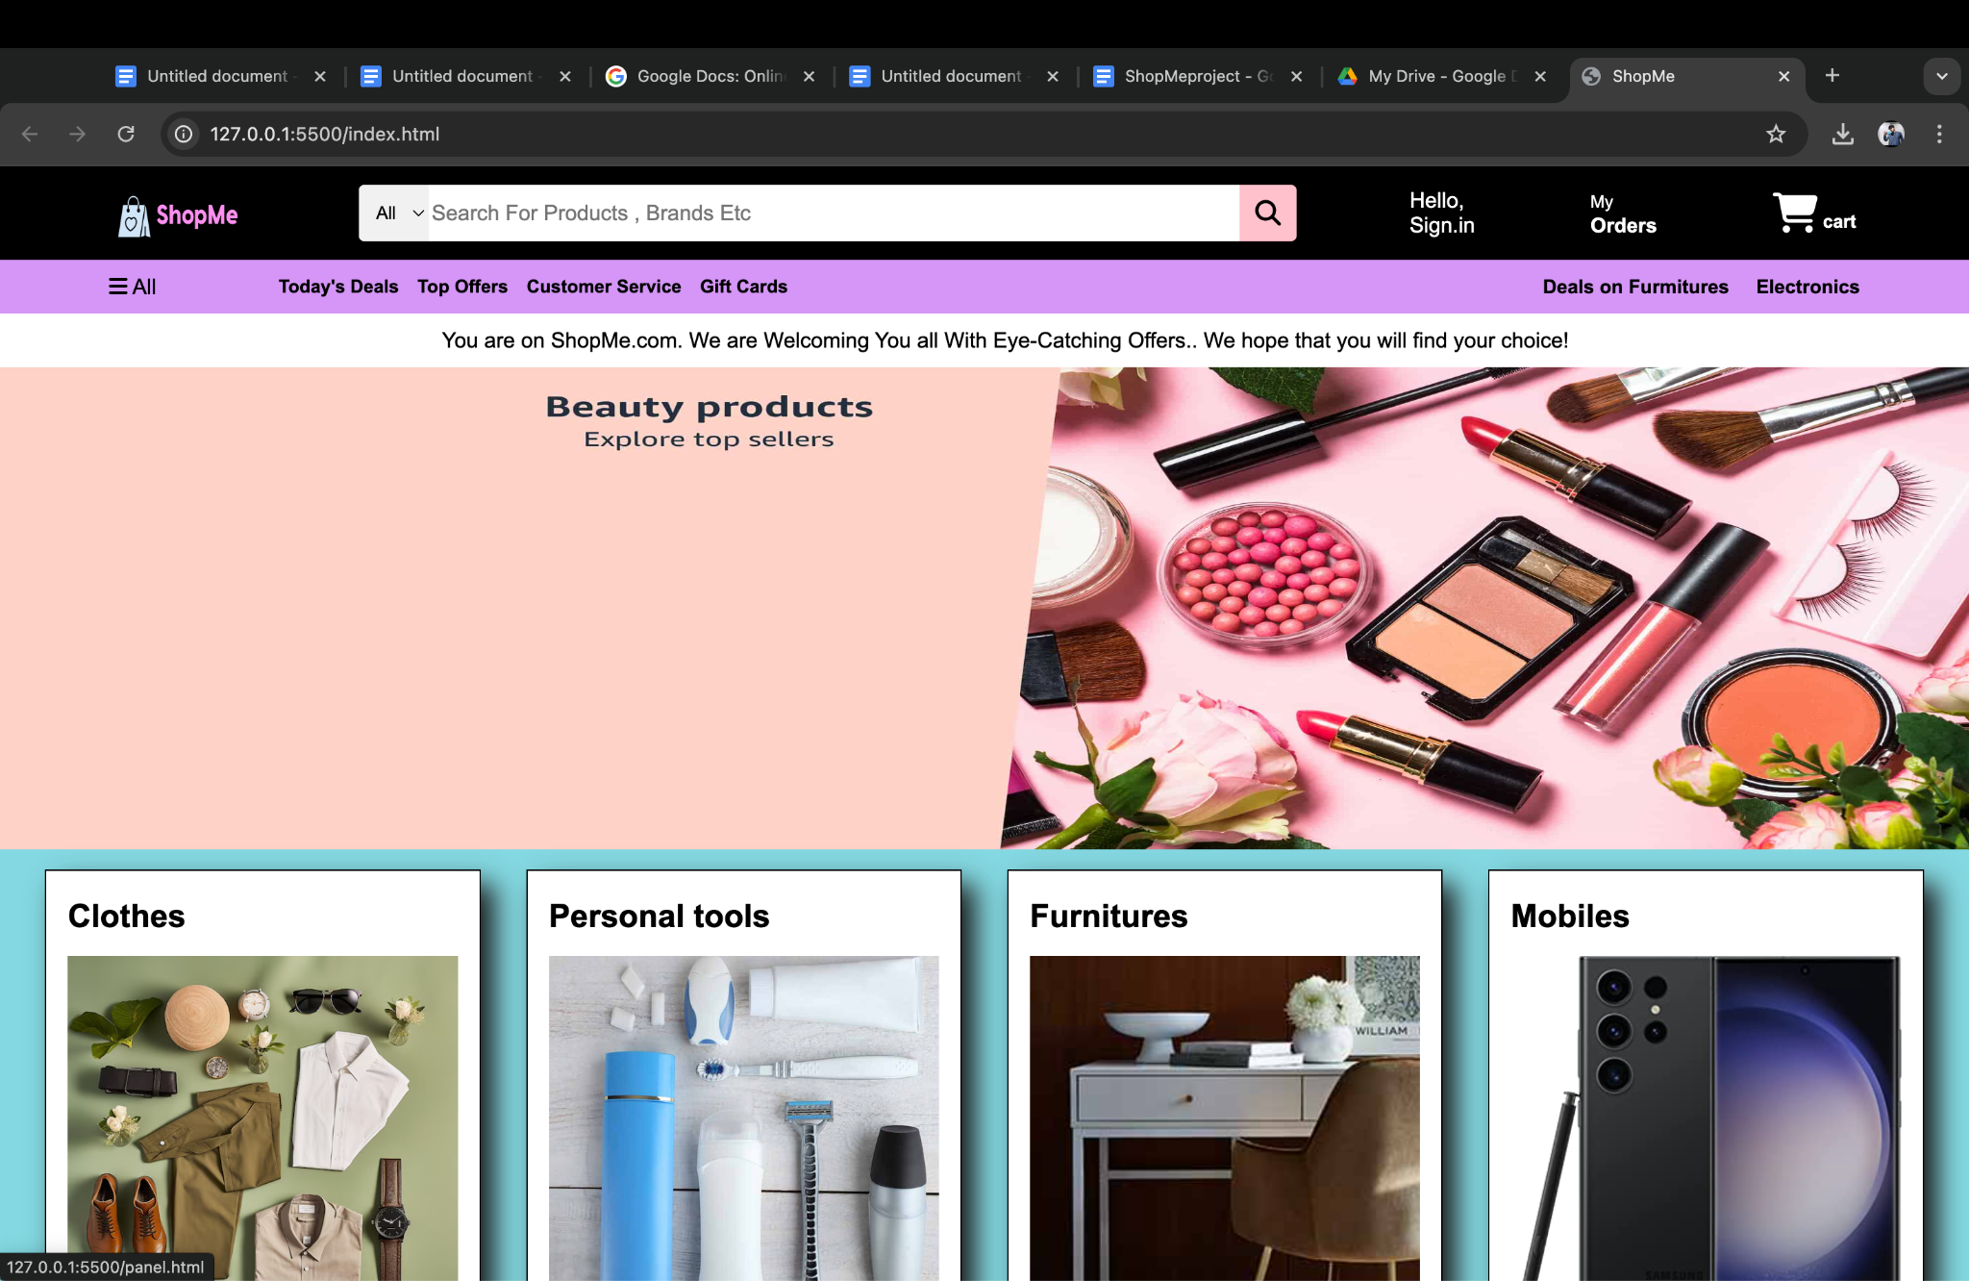

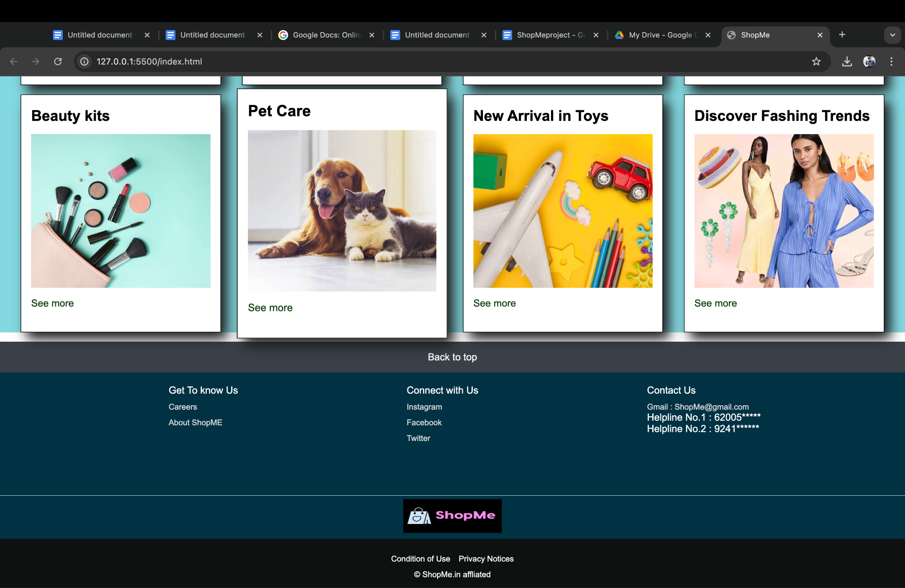

AFTER CLICKING ON AN IMAGE (BEAUTY PRODUCTS) BELOW THE WELCOMING MESSAGE:

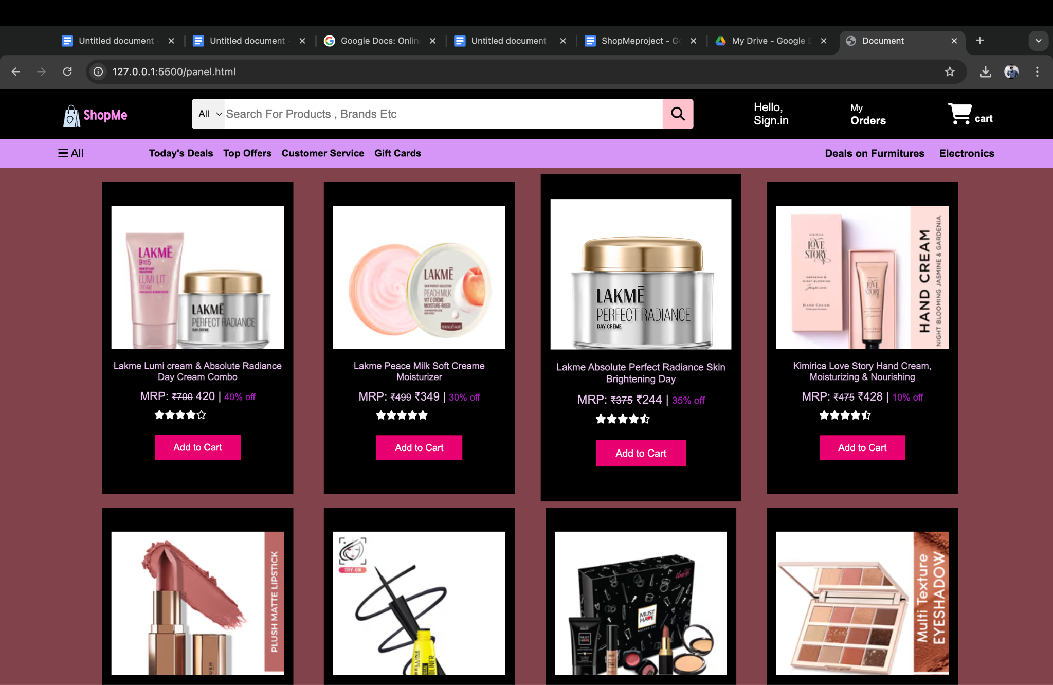

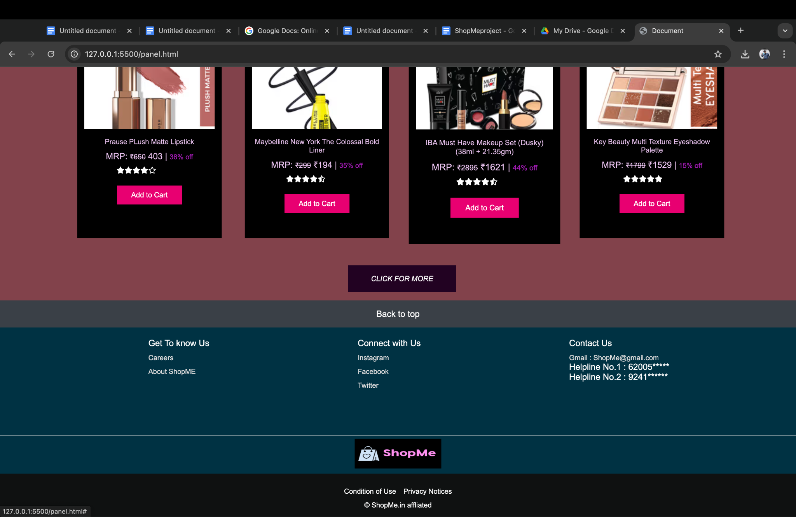

AFTER CLICKING ON SEE MORE IN CLOTHES SECTION:

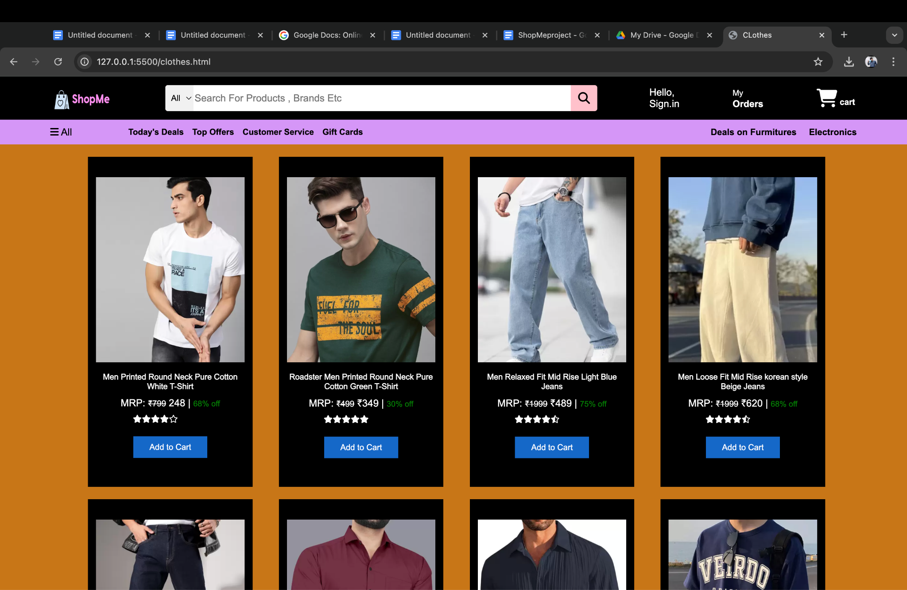

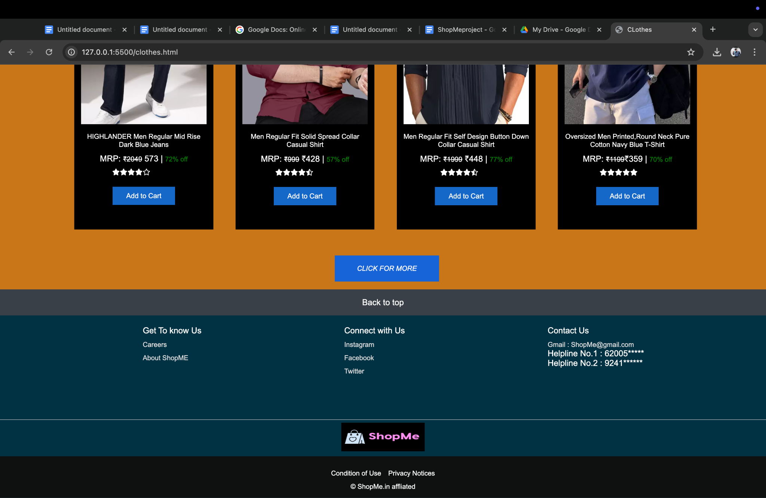

AFTER CLICKING ON SEE MORE IN MOBILES SECTIONS: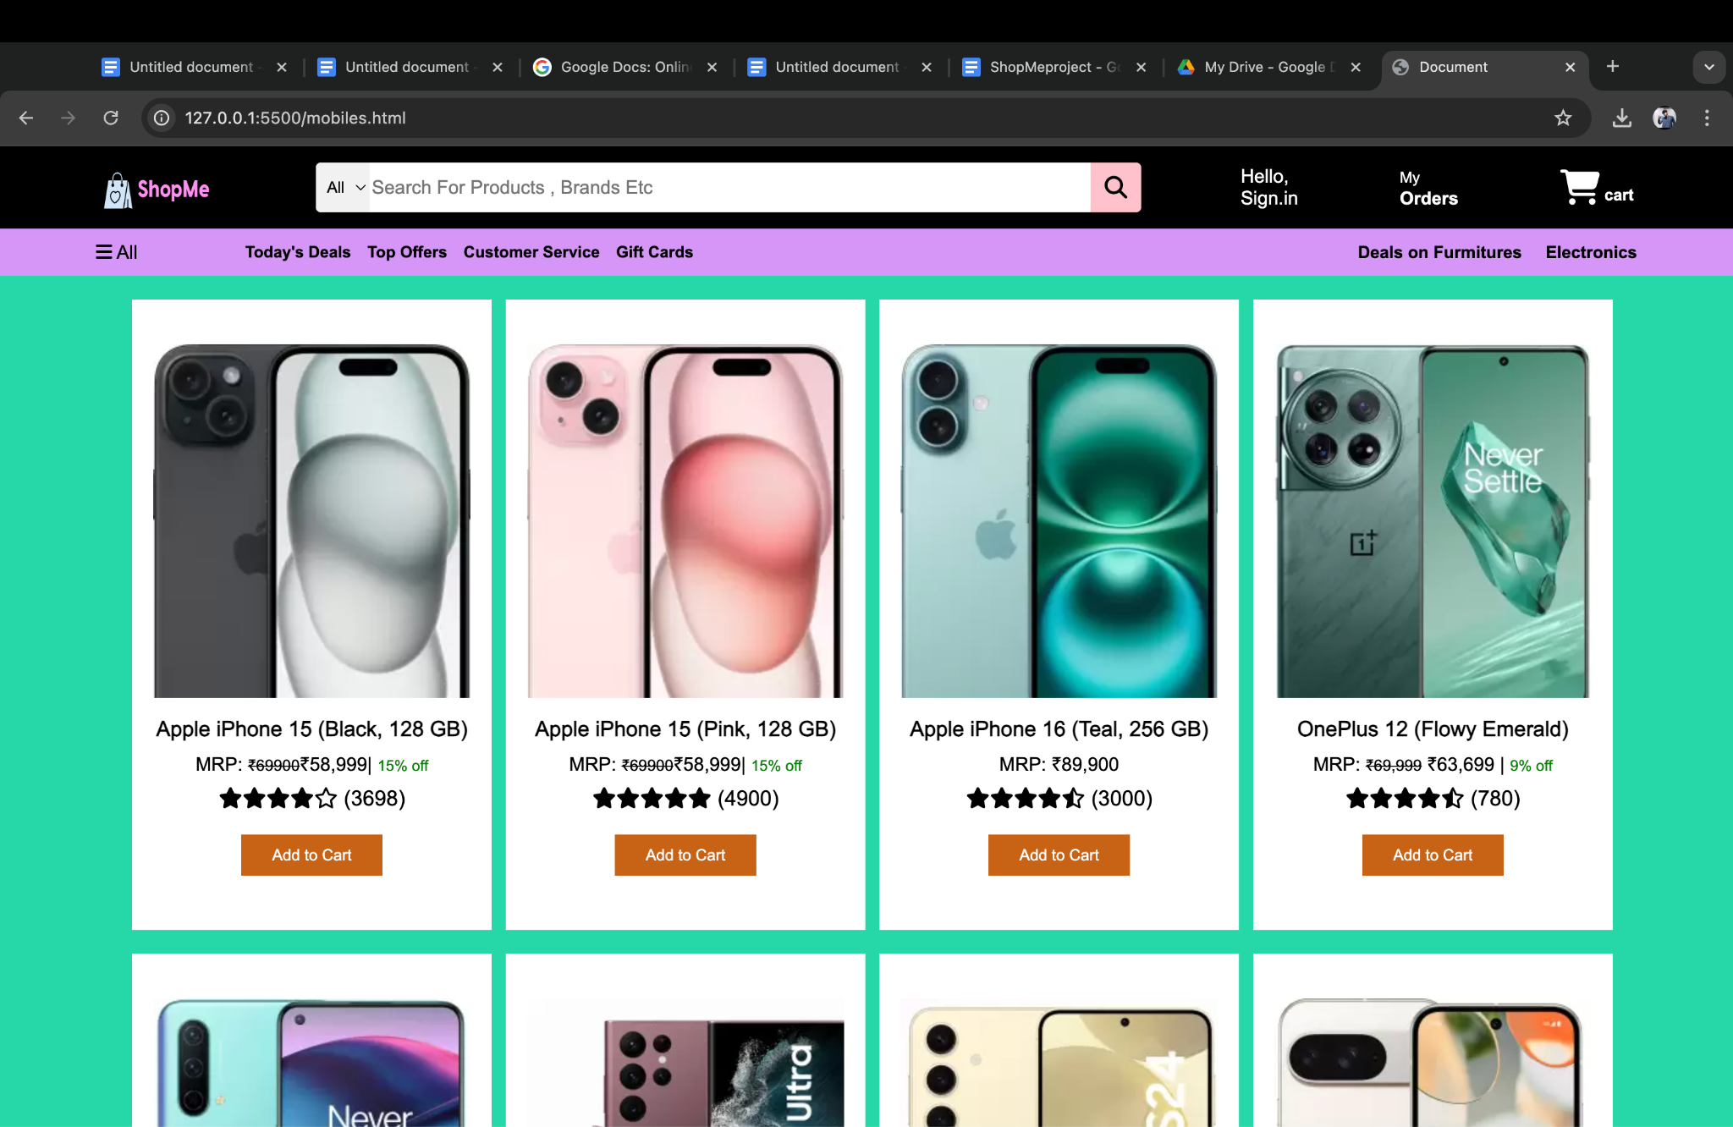

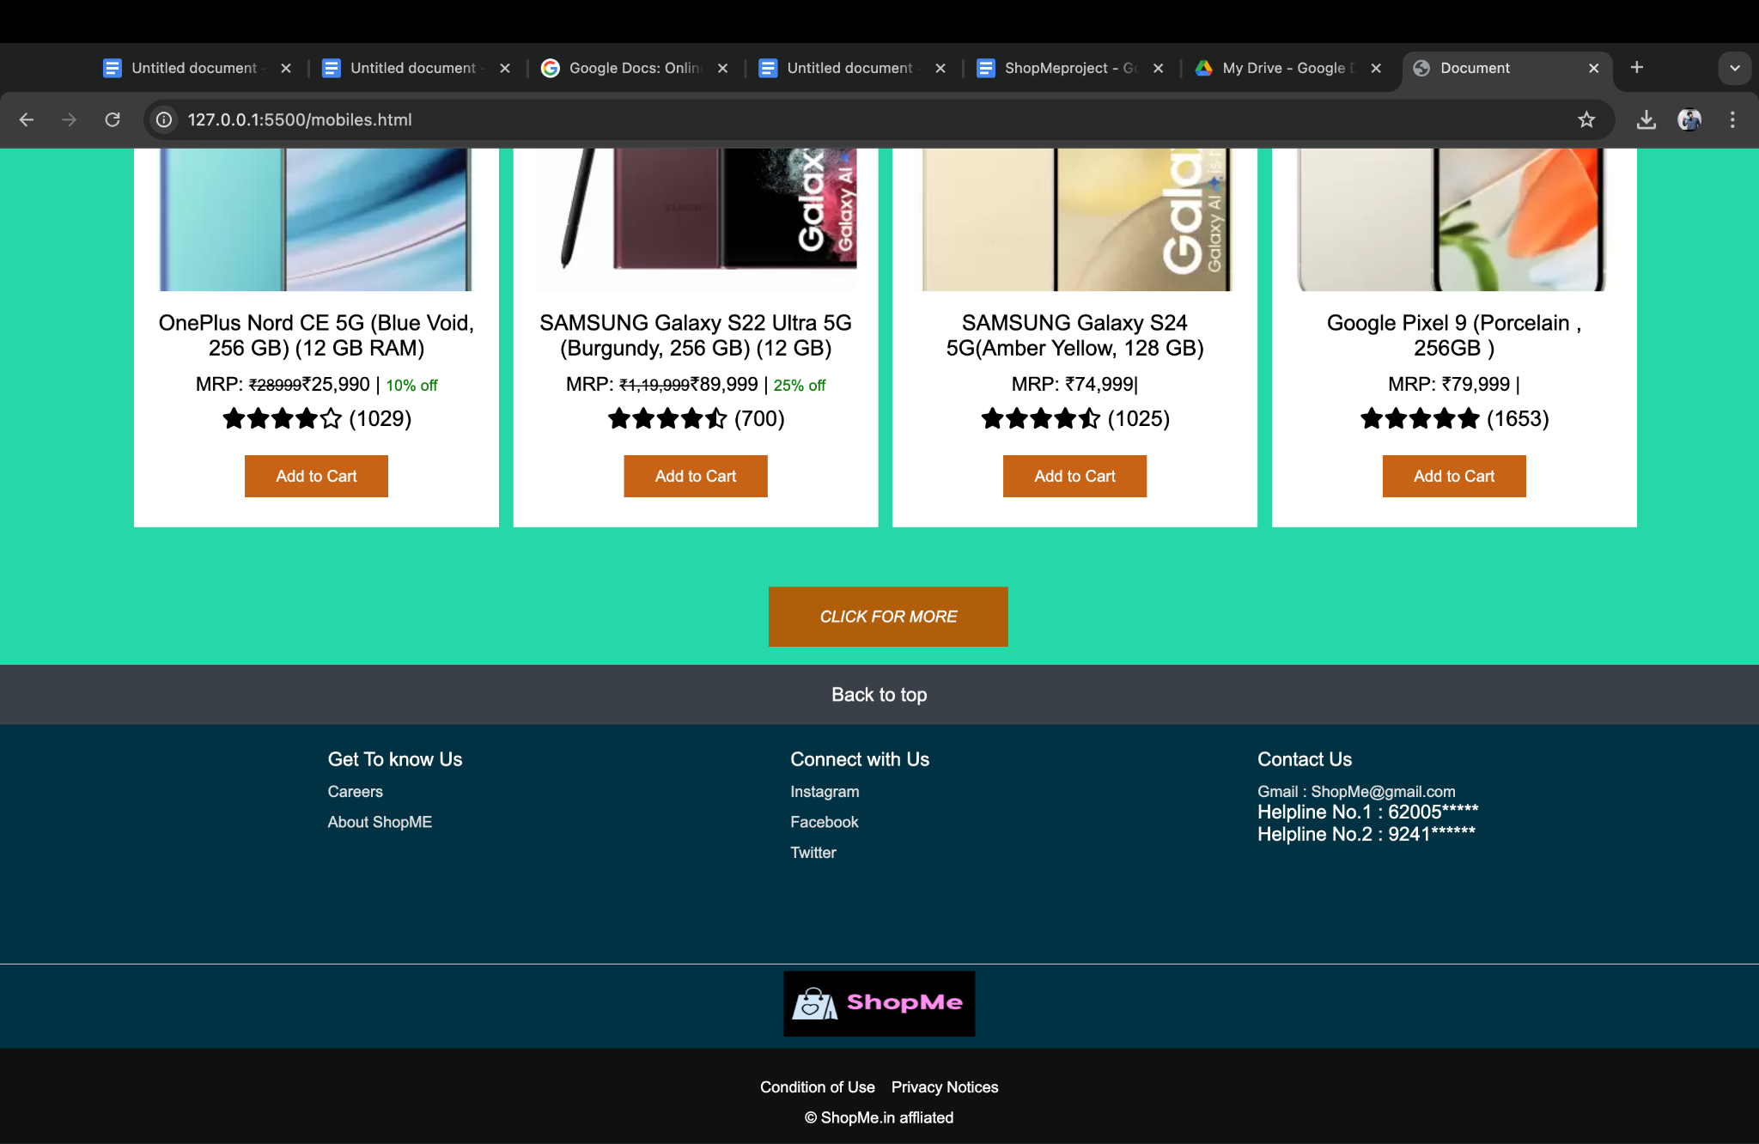

**Reference Links:**

Google: <https://www.google.co.in/>

Flipkart: <https://www.flipkart.com/>

Amazon: <http://www.amazon.com/>

Youtube: <https://www.youtube.com/>

Fonts and Icons: <https://fontawesome.com/>

Youtube: From Apna College.

And Guided by Gauri Thakur.